Variation in sexual size dimorphism and fit to Rensch's rule in Costa Rican hummingbirds

Gerardo Avalos^{1,2*}, Felipe Triana^{1,3}, Jeremy Klank^{1,3}, ¹Marcelo Araya

¹Escuela de Biología, Universidad de Costa Rica, 11501-2060 San Pedro, San José, Costa
Rica; Gerardo.avalos@ucr.ac.cr
²The School for Field Studies, Center for Sustainable Development Studies, 100 Cummings
Center, Suite 534G, Beverly, MA 01915, USA; gavalos@fieldstudies.org
³Instituto Clodomiro Picado, Universidad de Costa Rica, Coronado, San José, Costa Rica.

*Correspondence

Running title: Sexual size dimorphism and Rensch´s rule in Costa Rican hummingbirds

Abstract
Variation in sexual size dimorphism and fit to Rensch's rule in Costa Rican hummingbirds

Introduction: Following Rensch’s rule, increasing body mass is coupled with increased sexual size dimorphism (SSD) in species where males are the larger sex, whereas in species where females are larger, SSD decreases with body mass.
Objective: To analyze the variation in SSD for body mass and its adjustment to Rensch´s rule in 45 species of Costa Rican hummingbirds.
Methods: We examine the fit to Rensch´s rule SSD in body mass in 45 hummingbird species. We expected physiological constraints to limit SSD variation since hummingbirds have high metabolic rates, high dependence on energy-dense food, and high costs imposed by small size and hovering flight, which scale with body mass and elevation. Large species should be physiologically more capable of withstanding greater variation in SSD compared to small species, which are more energetically limited.
Results: Hummingbirds showed mixed allometry and fit Rensch's rule (slope of the RMA regression male vs female body mass = 0.84). Eighty percent of the species showed male-biased allometry in body mass. Average variation in SSD associated to weight was 12% and varied with size in males. Physiological limitations act on hummingbirds as a group limiting the magnitude of variation in SSD independently of body mass.
Conclusions: SSD in body size influences ecological performance, sexual displays, resource access, and foraging behavior. The SSD mixed allometry, and the positive relationship between the absolute value of SSD in males, suggests that selective pressures act differentially on the sexes and influence sexual niche segregation. Future research should examine intersexual variation in morphology, and quantify intersexual habitat use, niche segregation, and interspecific and intraspecific competition, targeting species located at the extremes of the Rensch's rule scatterplot.

Key words: display agility hypothesis, hummingbird ecology, mating competition hypothesis, physiological limits to SSD, sexual size dimorphism, sexual selection.

Total words: 6031

Differences in body mass between the sexes are widely distributed across a diverse variety of organisms, from vertebrates (Fairbairn, 1997) to arthropods (Blanckenhorn et al., 2007). This morphological differentiation between males and females associated with size has been termed “sexual size dimorphism” (SSD). SSD has important selective consequences since it influences trophic niche segregation (i.e., Bravo et al., 2016), specialization in reproductive roles, and reproductive success (Kingsolver and Huey, 2008; Herczeg et al., 2010). The variation in SSD has been attributed to diverse ecological and evolutionary explanations (Webster, 1992; Székely, 2007). These include classic sexual selection theory (Darwin, 1871; Payne, 1984; Dale et al., 2007) such as the mating competition (i.e., large males are better competitors) and display agility hypotheses (small males are more agile in sexual displays, Székely et al., 2007), the sexual niche segregation and specialization for food resources hypothesis (Temeles et al., 2010; Maglianesi et al., 2022), size- and sex-dependent predation risk (Blanckenhorn, 2005), correlational selection (i.e., morphological changes in one sex affecting the morphology of the opposite sex, Fairbairn, 1997), as well as phenotypic plasticity related to environmental changes influencing the expression of sex-related differences in ontogenetic trajectories, reproductive allocation, and body mass (West-Eberhard, 2003).
In addition to sexual selection explanations, the hypothesis of specialization in reproductive roles and sexual niche segregation (Slatkin, 1984) suggests that SSD is caused by differential ecological? selective pressures acting upon males and females leading to intersexual niche divergence. These explanations are not mutually exclusive and could be operating simultaneously. In addition, the mating system (e.g., polygyny in lekking species vs. monogamy), and the breeding aggregation of one sex, could intensify intraspecific competition for mates and thus increase the magnitude of SSD. Sexual selection goes beyond morphological traits and includes characters such as differences in vocalizations and plumage in birds, and behavioral displays (i.e., lekking behavior). Additional selective pressures, not directly related to sexual selection, could also act on SSD, such as the increase in brain size in relation to body mass in hummingbirds (see Ocampo et al., 2018), which impacts foraging behavior and habitat selection (Gonzalez-Gomez et al., 2014). Disentangling the evolution of the allometry of SSD implies understanding many of the key questions in evolutionary biology, such as the evolution of groups of correlated traits, and the influence of phenotype plasticity associated to the expression of SSD. Field studies estimating population parameters affecting the evolution of size and of SSD are needed to distinguish between overlapping hypotheses.
Rensch (1950) was among the first to observe that in species where males are larger than females, SSD increases with increasing body mass (hyperallometry) whereas in species where females are larger, the pattern is reversed, and thus relative differences in SSD decrease with decreasing body mass (hypoallometry, Rensch, 1950). This pattern is known as Rensch's rule and is predominant across a variety of taxa, including birds, mites, primates, lizards, snakes, and turtles (Blackenhorn, 2005). However, the causes responsible for SSD leading to Rensch´s rule remain unclear, although explanations based on the comparative analyses of diverse bird groups converge on sexual selection leading to mate competition and higher sexual display agility (Székely et al., 2007) as the primary cause of SSD. Natural selection, as well as physical and physiological constraints, set sex-specific upper and lower limits on body mass, and thus define the extent of variation in SSD.
Hummingbirds (Trochilidae) exhibit a broad range of SSD, including mixed allometries, with species in which females are the larger sex, as well as species in which males are larger. Some hummingbirds show sex segregation in habitat and resource use (Howell and Gardali, 2003; Leimberger et al., 2022). Males and females have distinctive reproductive roles and polygynous reproductive systems, where leks are prevalent. Some hummingbirds may have reached the upper energetic limits of miniaturization of any group of flying vertebrates, adapting their physiology to conserve heat in cold nights in some of the higher elevation habitats colonized by small vertebrates (Shankar et al., 2022). Their high metabolic rates force them to secure almost constant access to high-energy food sources, in addition to placing severe constraints on their ability to deal with environmental variation, although this has not been an obstacle for the colonization of high-altitude habitats (Altshuler and Dudley, 2002). The quality of food resources, as well as morphological limitations in accessing floral resources, impacted the evolution of hummingbird morphology and physiology due to considerable energy constraints associated with miniaturization and their high dependency on nectar consumption (see Kessler et al., 2020). All of these reasons make hummingbirds an ideal group to examine the selective pressures influencing SSD allometry (Colwell, 2000).
The objective of this study is to quantify the extent of SSD variation in body mass and the fit to Rensch´s rule in 45 of Costa Rica's 52 species of hummingbirds and investigate possible explanations for such variation. We include the largest hummingbird in Costa Rica, the Violet Sabrewing (Campylopterus hemileucurus), and one the smallest species, the Scintillant Hummingbird (Selasphorus scintilla). We propose the hypothesis that the physiological capacity to buffer morphological changes, which varies with body mass, can explain the extent of variation in SSD. Large size provides better physiological buffering against environmental challenges, such as food shortages and extremes in environmental variables. Since large species would have more physiological plasticity to adapt to environmental changes, we would expect greater variation in SSD in these species than in small species, which are more energetically limited. Greater variation in SSD should reinforce sexual niche segregation. Due to greater physiological limitations, small species should present a smaller range of morphological variation between males and females than larger species. Our results will emphasize the importance of examining male- and female-biased allometries and help establish future directions in the analysis of the ecological importance of SSD in hummingbirds.

MATERIALS AND METHODS

Sources of morphological data: For our analysis, we used three sources of morphological data: a) our own database of 19 hummingbird species representing 731 mist net captures registered between 2012 and 2016 in different sites in Costa Rica, b) we compiled data from 35 species from the bird collection of the Museum of Zoology at the University of Costa Rica (154 specimens), and c) the e-bird platform (https://birdsoftheworld.org/bow/home?) from Cornell University Ornithology Laboratory to gather body mass data. Using these three sources, we assembled information on body mass for 45 hummingbird species (i.e., the large dataset, Table 1). We analyzed SSD using body mass (g) because this morphological variable is the most frequently reported in the literature (often the only one reported), as well as in databases and museum specimens, and is correlated with resource access (Dalsgaard et al., 2009). We used the classification of McGuire et al. (2014) to distribute the 45 species into eight of the nine hummingbird phylogenetic clades (i.e: Bees, Coquettes, Hermits, Brilliants, Emeralds, Mangoes, Mountain Gems and Topazes)

Lovich-Gibbons sexual dimorphism index: We calculated the Lovich-Gibbons ratio (Lovich and Gibbons, 1992) to quantify SSD for body mass. This index of sexual dimorphism is the ratio of the average body mass of the larger sex over the average body mass of the smaller sex minus 1. The index is positive when females are the larger sex and arbitrarily declared negative when males are the larger sex. Since this index is a ratio, it can also be expressed as a percentage of SSD. For instance, in S. flammula the index is 0.096 (Table 1), and it shows that females are 9.6% larger than the males. The Lovich-Gibbons ratio followed a normal distribution (Shapiro-Wilk test = 0.96, P = 0.28).

Statistical Analyses: We designated the body mass of males as predictor and the body mass of females as the response, following the traditional convention (e.g., Colwell, 2000). To test the hypothesis that SSD is greater in larger species and smaller in smaller species, we investigated the relationship between species body mass and SSD using bayesian linear regression models in the R package brms (Bürkner, 2017). We used a gaussian Bayesian model and estimated the Pearson correlation coefficient to examine this relationship, specifically correlating the absolute value of SSD (calculated using the Lovich–Gibbons ratio) with the body mass of both males and females. To account for phylogenetic bias and uncertainty in our data, we used 100 trees from the posterior tree distribution obtained by McGuire et al. (2014) and added a phylogenetic covariance matrix as a random effect in our model. Posterior distribution of parameters of models from different trees were combined
into a single model fit. This approach allows us to incorporate the evolutionary relationships among species, while accounting for the non-independence due to shared evolutionary history. All the analyses were conducted using R 3.6.0 (R Core Team, 2019).

RESULTS

Our data showed a wide range in the magnitude of body mass across species, from the largest hummingbird in Costa Rica, the male Violet Sabrewing, C. hemileucurus (12.42g, n = 11), and the White-tipped Sicklebill, Eutoxeres aquila, the largest female (10.11 g), to the Scintillant Hummingbird, Selasphorus scintilla, the smallest species for both males (2.05g) and females (2.3 g, Table 1).

Fit to Rensch´s Rule: We found a significant relationship between the Log10 of male and female body mass (Fig 1; Table 2, Intercept=0.09, Slope=0.84). The slope of the regression was <1 indicating conformity with Rensch’s rule. The magnitude of the regression slope shows divergence from isometry, indicating mixed allometry. In this case, large, male-biased species were at the upper end, and small, female-biased species were at the lower end of the scatter plot (Fig 1).
SSD increased with male size (i.e., weight, Table 2, intercept= 0.01, slope = 0.15) but did not increase with female size (Table 1, intercept = 0.05, slope =0.10, Fig. 2). The Lovich-Gibbons ratio of sexual dimorphism in the large dataset showed that Bees and Coquettes were on the positive side of the chart (indicating female-biased SSD), whereas large-sized clades were on the negative side (indicating male-biased SSD, Fig. 3). However, Mangoes, Emeralds, and Hermits had species in which females were larger than males, although as a group, the dimorphism was male-biased. Of the 45 hummingbird species examined, 36 (80%) showed male-biased SSD.

Test of the hypothesis of physiological limits to SSD associated to body mass: Although hummingbirds fit Rensch's rule, 48% of the species (n = 22) showed less than 10% of SSD variation in body mass (Table 1, Fig. 3). There were 18 species with SSD higher than 10%. This group included C. hemileucurus, Lampornis castaneoventris, Colibri delphinae, and Microchera cupreiceps, which showed an SSD over 30%. Except for C. hemileucurus, these were mid-size species (<8 g, but >4 g). Thus, our prediction that the largest species will show higher variation in SSD, as a general trend, was true for large and some mid-size species. Finally, the species with less than 5% variation in SSD included a small number of mid-size species (n = 6), and these were Threnetes ruckeri, Glaucis aeneus, Microchera albocoronata, Chlorestes candida, Heliothryx barroti and Saucerottia hoffmanni. Our prediction that the smallest species will show less variation in SSD was not supported by the data. The relationship between body mass and the absolute value of Lovich-Gibbons ratio (Fig 2) was significant for males but not for females shows that there is a stronger selection pressure on increasing dimorphism with body size in males rather than in females. The average absolute value of the Lovich-Gibbons ratio was 0.12 ± 0.08 (12% variation in SSD across the 45 species), and was male-biased.

DISCUSSION

Hummingbirds showed mixed allometries and a predominance of male-biased body mass, which is the general trend for most bird groups (Székely et al., 2007). Using a similar analysis for 154 hummingbird species, Colwell (2000) also reports mixed allometry and the same slope value (0.84) to the one found here. Abouheif and Fairbairn (1997) propose that if 80% or more of the species in a group showed that males are larger than females, then the taxon should be characterized as male-biased. This was the case in this study since 80% of the 45 hummingbird species showed male-biased SSD in body mass. Large males are usually better competitors for food resources and are better in combat to access females. However, for the species with the inverse pattern (i.e., reversed sexual dimorphism, RSD, where females are larger than males), aerodynamics, and maneuverability (aerial agility hypothesis, Raihani et al., 2006) could affect SSD and favor intersexual niche divergence since morphological characters are subject to different selective pressures between males and females. Males of smaller species do complex, acrobatic displays for females, and thus, traits related to aerodynamics, such as wing area and wing loading, could influence their reproductive success (i.e., the elaborated aerial displays of small species such as S. flammula and S. scintilla. Clark et al., 2011). In small species, the cost of reproduction (e.g., egg production) is proportionally higher for females, favoring a larger size in this sex relative to males (Wheeler and Greenwood, 1983). Other alternative explanations to SSD, such as the intersexual niche divergence hypothesis, where sexes have evolved different sizes to lessen intersexual competition for food, and the small-male hypothesis, where small males are more efficient foragers (Krüger, 2005), could combine to explain the differences in SSD observed here among large and small hummingbird species. There is also a sexual selection effect, which is reflected in the dimorphism in plumage color, as well as in the expression of exaggerated traits, such as very elongated feathers on the tail, crown, and throat of some species, and that could extend to body mass and flight agility.
Field experiments are lacking to test these hypotheses, but the results from this study can guide future research to examine the causes of SSD in hummingbirds with large and small variations in SSD. For instance, in small species such as S. flammula (SSD = 9.6%), we have observed habitat segregation. Males are more common in paramo vegetation, above the tree line, whereas females prefer forest edges and gaps, and the interior of oak forests. Intersexual habitat segregation has also been reported in S. sasin and S. rufus in California, United States, where males and females forage in different habitats (Howell and Gardali, 2003).

Causes of variation in SSD: Although hummingbirds fit Rensch's rule by showing mixed allometry, 48% of the species displayed a modest variation in SSD for body mass (less than 10%). Only 5 species, including the small bees and coquettes, and the Stripe-throated Hermit, Phaethornis striigularis (mean body mass 2.6 g) showed RSD, ranging 10 to 17%. The largest species, C. hemileucurus, exhibited a large variation in SSD biased towards males. In this species, the male is, on average, 36% heavier than the female. Body mass in this case provides a competitive advantage to access food resources. We have observed that male C. hemileucurus dominate competitive interactions around artificial feeders, and thus displace C. hemileucurus females, as well as males and females from mid-size 6 species.
The average variation in the absolute value of SSD for body mass across species was 12%, which we considered moderate (Fairbairn, 2007). Instead of scaling with body mass, the hypothesis of physiological limits to SSD could apply to hummingbirds as a group, regardless of body mass. This is because the high metabolic rates of hummingbirds in general, their high dependence on access to high-energy food (which must be supplied almost constantly), and the high energy costs imposed by small size and hovering flight, may limit the range of variation in body mass altogether, as well as between sexes, despite of differential selective pressures leading to SSD in males and females.
In contrast to our hypothesis, we did not find a clean trend of increasing variation in SSD from small to large hummingbirds. We expected that greater SSD would be more common in larger species. The smaller and more energetically limited species would show a lower capacity for high variation in SSD. Implicit in our hypothesis was the expectation that high variation in SSD could trigger a higher differentiation in intersexual niche divergence. In contrast, we observed a relatively modest variation in SSD (Székely et al., 2007). Although we might expect differences in SSD to translate into changes in functional performance, such as competition for resources (Maglianesi et al., 2022), and in the intensity of intersexual and intrasexual selection (Payne, 1984), hummingbirds can also show a high plastic behavior to access resources, buffering the effects of morphological differences. Intra and interspecific differences in size, while important in determining competitive hierarchies and resource access, can be buffered through behavioral changes reflected in opportunistic foraging as well as nectar robbing (Ornelas, 1994; Boehm, 2018). Behavioral plasticity makes it possible to circumvent morphological limitations in accessing resources and this takes place across the whole range of body mass.
However, the relationship between body mass and the absolute value of SSD increased with overall hummingbird size only in males. This suggests that selective pressures act differentially on the sexes and potentially influence sexual niche segregation. The primary causes of this variation need to be further explored through field studies quantifying intraspecific and intersexual morphological variation. SSD has been analyzed using the ratio of average values ​​of morphological characters for males and females, usually obtained from museum specimens and very small samples, which ignores the intraspecific and intersexual variation of different characters in addition to body mass. This flaw has been pointed out before (Smith, 1999), and as found here, the variation associated to one trait and sex is lost when the analysis is done using the ratio of average values, which does not incorporate the variation around the mean.

Other morphological traits influencing SSD: Body mass is not the only morphological trait with a significant effect on competitive performance, foraging behavior, or resource access despite of being the most analyzed character used to summarize differences in SSD (i.e., Fairbairn, 1997; Colwell, 2000). Body mass is regularly recorded in field studies as well as in museum specimens. The influence of other traits on SSD should be further explored. For instance, the size of the hallux allows mountain gem species with relatively large legs, such as Panterpe insignis, to perch while foraging, which saves energy by avoiding hovering flight (R. Colwell, pers. com.) In addition, long-billed hummingbirds could access a wider variety of corolla lengths than short-billed ones, including legitimate and non-legitimate visits (Rojas-Rodríguez et a. 2023). Opportunistic and non-specialized foraging is common in many pollination networks (Simmons et al., 2019). Bill length and morphology can be of great importance in affecting foraging for nectar and insects (Feinsinger and Colwell, 1978; Rico-Guevara et al., 2019), but so is the presence of bill serrations that favor nectar robbing by piercing corollas, as well as insect foraging (Ornelas, 1994). These bill serrations are secondary sexual characters influencing competitive interactions between males (Rico-Guevara and Araya-Salas, 2015).

Conclusions: The mixed allometry for SSD found here demonstrates that males and females are under different selective pressures for body mass. This includes sexual selection for larger males in large species and selection towards greater male agility in small species. We expected that physiological constraints related to body mass would explain the variation in SSD and that larger species would show greater variation in SSD. Instead, the average SSD variation in body mass was modest (12%) and was related to body mass only in males. This narrow range of variation accounts for the potential effects of physiological limitations restricting SSD in hummingbirds as a group, regardless of size. Hummingbird behavioral plasticity circumvents morphological limitations on resource access. Other characters, such as bill length and bill curvature, and the presence of bill striae, could facilitate nectar theft in some species, as well as insect foraging and competitive interactions between males.
Future lines of research should examine the levels of intraspecific and intersexual variation in SSD, which could be better understood with field data by quantifying more traits, measuring habitat and food resource use, and increasing the sample size for males and females. Analyzing SSD as a ratio of average trait values for males and females tells an incomplete story. Since the mixed allometry found in hummingbirds indicates different selective pressures acting on males and females, the variation around the mean of traits for males and females must be measured instead. Field experiments should quantify intersexual habitat use and niche segregation, the nature of sexual displays, and interspecific and intraspecific competitive interactions, at least for the species that lie at opposite ends of the continuum of Rensch's rule scatterplot.

ACKNOWLEDGMENTS

Keilor Rojas Jiménez facilitated the participation of FT and JK and triggered the writing of this manuscript. Robert Colwell read an early version of this manuscript and made comments that significantly improved the final version. Ignacio Gutiérrez allowed access to the ornithology database of the Museum of Zoology at the University of Costa Rica. Jim McGuire facilitated the phylogenetic data. We thank Génesis Coto for her initial comments on data collection.

RESUMEN
Variación en el dimorfismo del tamaño sexual y ajuste a la regla de Rensch en colibríes de Costa Rica
Introducción: Según la regla de Rensch, en especies donde los machos son más grandes, el aumento de la masa corporal varía proporcionalmente con el aumento del dimorfismo de tamaño sexual (DTS), mientras que en especies donde las hembras son más grandes, DTS disminuye con la masa corporal.
Objetivo: Explicar la variación de DTS para la masa corporal y su ajuste a la regla de Rensch en 45 especies de colibríes de Costa Rica.
Métodos: Examinamos DTS en masa corporal en 45 especies, y DTS en longitud de pico y tamaño de ala en nueve especies para las cuales teníamos datos detallados, y su ajuste a la regla de Rensch. Esperábamos que las restricciones fisiológicas limitaran la variación de DTS, ya que los colibríes tienen altas tasas metabólicas, una alta dependencia de alimentos densos en energía y altos costos energéticos impuestos por el pequeño tamaño y el vuelo suspendido, los que escalan con la masa corporal y la elevación. Las especies grandes deben ser fisiológicamente capaces de soportar una mayor variación en DTS en comparación con las especies pequeñas, que son más limitadas energéticamente.
Resultados: Los colibríes mostraron alometría mixta y se ajustaron a la regla de Rensch (pendiente de la regresión RMA entre masa corporal masculina vs femenina = 0.8630). El ochenta por ciento de las especies mostraron alometría sesgada hacia los machos en la masa corporal. La variación promedio en DTS fue del 12% y varió independientemente del tamaño. Las limitaciones fisiológicas actúan sobre los colibríes como un grupo y limitan el TDS independientemente de la masa corporal.
Conclusiones: TDS en tamaño corporal, longitud del pico y área del ala influye en el rendimiento ecológico, las exhibiciones sexuales, el acceso a los recursos y el comportamiento de búsqueda de alimento. La alometría mixta SSD, y la relación positiva con la desviación estándar de la masa corporal, la cuerda del ala y el área del ala en relación con el tamaño para machos de nueve especies, sugiere que las presiones selectivas actúan de diferencialmente sobre los sexos e influyen en la segregación del nicho sexual. La investigación futura debería examinar la variación intersexual en la morfología y cuantificar el uso del hábitat intersexual, la segregación de nichos y la competencia interespecífica e intraespecífica, apuntando a especies ubicadas en los extremos del diagrama de dispersión de la regla de Rensch.

Palabras clave: hipótesis de agilidad de despliegue; ecología de colibríes; hipótesis de competencia de apareamiento: límites fisiológicos de TDS; dimorfismo de tamaño sexual; selección sexual.

Funding: this research was supported by The School for Field Studies and the University of Costa Rica.

Conflicts of interest: the authors express no conflicts of interest.

Ethics approval: the authors expressed they followed the Committee on Publication Ethics (COPE) regulations.

Consent to participate: all the authors agreed to contribute intellectually to this research.

Consent for publication: all the authors approved the last version of the manuscript.

Availability of data and material: The data used in this publication is included in the Supplementary Materials.

Authors' contributions: GA conceived the idea, collected the field data, and wrote the manuscript. FT and JK Contributed data. All authors analyzed the data and edited the manuscript.

REFERENCES

Abouheif, E. & Fairbairn, D. J. (1997). A comparative analysis of allometry for sexual size dimorphism: assessing Rensch's rule. Am. Nat. 149(3): 540-562.
Altshuler, D. L. & Dudley, R. (2002). The ecological and evolutionary interface of hummingbird flight physiology. J. Exp. Biol. 205(16): 2325-2336.
Blanckenhorn, W. (2005). Behavioral Causes and Consequences of Sexual Size Dimorphism. Ethol. 111: 977-1016
Blanckenhorn, W. U., Meier, & R., Teder. T. (2007). Rensch’s rule in insects: patterns among and within species, Oxford, Uk, pp 60-70
Boehm, M. (2018). Biting the hand that feeds you: wedge-billed hummingbird is a nectar robber of a sicklebill-adapted Andean bellflower. Acta Amazon. 48: 146-150.
Bravo C, Ponce C, Bautista LM, Alonso JC (2016) Dietary divergence in the most sexually size-dimorphic bird. The Auk Ornithol Adv 133(2):178-197
Bürkner, P. C. (2017). brms: An R package for Bayesian multilevel models using Stan. J. Stat. Softw. 80: 1-28.
Chou C-C, Iwasa Y, Nakazawa T (2016) Incorporating an ontogenetic perspective into evolutionary theory of sexual size dimorphism. Evolution 70:369-384
Clark C, Feo T, Escalante I (2011) Courtship Displays and Natural History of Scintillant (Selasphorus scintilla) and Volcano (S. flammula) Hummingbirds. Wilson J Ornith 123:217-228
Colwell R (2000) Rensch’s Rule Crosses the Line: Convergent Allometry of Sexual Size Dimorphism in Hummingbirds and Flower Mites. Am Natur 156:495-510
Dale J, Dunn P, Figuerola J et al (2007) Sexual selection explains Rensch’s rule of allometry for sexual dimorphism. Proc R Soc London Ser B 274:2971-2979
Dalsgaard B, Martín González AM, Olesen JM et al (2009) Plant–hummingbird interactions in the West Indies: floral specialisation gradients associated with environment and hummingbird size. Oecologia 159(4):757-766
Darwin CR (1871) The Descent of Man, and Selection in Relation to Sex. John Murray, London
Fairbairn D (1997) Allometry for Sexual Size Dimorphism: Patterns and Process in the Coevolution of Body Size in Males and Females. Annu Rev Ecol Sys. 28:659-687
Fairbairn D (2007) Introduction: the enigma of sexual size dimorphism. In: Fairbairn DJ,
Feinsinger P, Colwell R (1978) Community organization among neotropical nectar-feeding birds. Am Zool 18:779-795
Gonzalez-Gomez PL, Madrid-Lopez N, Salazar JE et al (2014) Cognitive ecology in hummingbirds: the role of sexual dimorphism and its anatomical correlates on memory. PLoS One 9(3):e90165
Herczeg G, Gonda A, Merilä J (2010) Rensch’s rule inverted – female-driven gigantism in nine-spined stickleback Pungitius pungitius. J Anim Ecol 79:581-588
Howell SN, Gardali T (2003) Phenology, sex ratios, and population trends of Selasphorus hummingbirds in central coastal California. J Field Ornith 74:7-25
Kessler M, Abrahamczyk S, Krömer T (2020) The role of hummingbirds in the evolution and diversification of Bromeliaceae: unsupported claims and untested hypotheses. Bot J Linn Soc 192(4):592-608
Kingsolver J, Huey R (2008) Size, temperature, and fitness: three rules. Evol Ecol Res 10:251-268
Krüger O (2005) The evolution of reversed sexual size dimorphism in hawks, falcons and owls: a comparative study. Evol Ecol 19(5):467-486

Leimberger KG, Dalsgaard B, Tobias JA et al (2022) The evolution, ecology, and conservation of hummingbirds and their interactions with flowering plants. Biol Rev 97:923-959
Lovich JE, Gibbons JW (1992) A review of techniques for quantifying sexual size dimorphism. Growth Develop Aging 56:269-269
Maglianesi MA, Maruyama PK, Temeles EJ et al (2022) Behavioural and morphological traits influence sex‐specific floral resource use by hummingbirds. J Anim Ecol DOI: 10.1111/1365-2656.13746
McGuire JA, Witt CC, Remsen Jr JV et al (2014) Molecular phylogenetics and the diversification of hummingbirds. Curr Biol 24(8):910-916
Ocampo D, Barrantes, G, Uy JAC (2018) Morphological adaptations for relatively larger brains in hummingbird skulls. Ecol Evol 8(21):10482-10488
Ornelas JF (1994) Serrate tomia: an adaptation for nectar robbing in hummingbirds? Auk 111(3):703-710
Payne RB (1984) Sexual selection, lek behavior, and sexual size dimorphism in birds. Ornithol Monogr 33:1–52
Quinn GP, Keough MJ (2002) Experimental design and data analysis for biologists. Cambridge, UK
R Core Team. (2019) R: A language and environment for statistical computing. R Foundation for Statistical Computing, Vienna, Austria. Available from https://www.R-project.org/

Raihani G, Székely T, Serrano-Meneses MA et al (2006) The influence of sexual selection and male agility on sexual size dimorphism in bustards (Otididae). Anim Behav 71(4):833-838
Rensch B (1950) Die Abhängigkeit der relativen Sexualdifferenz von der Körpergrösse. Bonner Zoologische Beiträge 1:58-69
Rico-Guevara A, Araya-Salas M (2015) Bills as daggers? A test for sexually dimorphic weapons in a lekking hummingbird. Behav Ecol 26(1):21-29
Rico-Guevara A, Rubega MA, Hurme KJ et al (2019) Shifting paradigms in the mechanics of nectar extraction and hummingbird bill morphology. IOB 1(1):oby006
Rojas-Rodríguez, P, Bianchi-Barrantes S, Avalos G (2023) Efecto de la longitud del pico sobre la especialización de la visitación floral de colibríes de zonas medias y altas de Costa Rica. Zeledonia 27(1):1-17
Shankar A, Cisneros INH, Thompson S et al (2022) A heterothermic spectrum in hummingbirds. J Exp Bio. 225:jeb243208
Simmons BI, Vizentin‐Bugoni J, Maruyama PK et al (2019) Abundance drives broad patterns of generalisation in plant–hummingbird pollination networks. Oikos 128(9):1287-1295
Slatkin M (1984) Ecological causes of sexual dimorphism. Evol 38(3):622-630
Smith RJ (1999) Statistics of sexual size dimorphism. J Hum Evolution 36(4):423-458
Szekely T, Lislevand T, Figuerola, J (2007) Sexual size dimorphism in birds. In: Fairbairn DJ, Blanckenhorn WU, Székely T (eds) Sex, size and gender roles: evolutionary studies of sexual size dimorphism, Oxford, UK, pp 27-37
Temeles EJ, Miller JS, Rifkin JL (2010) Evolution of sexual dimorphism in bill size and shape of hermit hummingbirds (Phaethornithinae): a role for ecological causation. Philos T R Soc B 365(1543):1053-1063
Torres, J. R., Infante-Mata, D., Sánchez, A. J., Espinoza-Tenorio, A., & Barba, E. (2017). Atributos estructurales, productividad (hojarasca) y fenología del manglar en la Laguna Mecoacán, Golfo de México. Revista de Biología Tropical, 65(4), 1592-1608.
Webster MS (1992) Sexual dimorphism, mating system and body size in New World blackbirds (Icterinae). Evolution 46(6):1621-1641
West-Eberhard MJ (2003) Developmental plasticity and evolution. Oxford, UK
Wheeler P, Greenwood PJ (1983) The evolution of reversed sexual dimorphism in birds of prey. Oikos 40(1):145-149.
TABLE 1
Body mass (g) and Lovich-Gibbons sexual dimorphism index of the 45 hummingbird species considered in this study according to phylogenetic clade and sex. Phylogenetic clades follow the classification of McGuire et al., (2014).

Common name | Scientific name | Phylogenetic clade | Body mass of male | Body mass of female | Lovich-Gibbons ratio
Magenta-throated Woodstar | Philodice bryantae | Bees | 3.3 | 3.5 | 0.061
Ruby-throated Hummingbird | Archilochus colubris |  | 2.7 | 3 | 0.111
Scintillant Hummingbird | Selasphorus scintilla |  | 2.05 | 2.3 | 0.122
Volcano Hummingbird | Selasphorus flammula |  | 2.5 | 2.74 | 0.096
Green-crowned Brilliant | Heliodoxa jacula | Billiants | 9.06 | 8.54 | -0.061
Black-crested Coquette | Lophornis helenae | Coquettes | 2.15 | 2.52 | 0.172
Green Thorntail | Discosura conversii |  | 3.1 | 2.9 | -0.069
Black-bellied Hummingbird | Eupherusa nigriventris | Emeralds | 3.425 | 3.25 | -0.054
Blue-chested Hummingbird | Polyerata amabilis |  | 4 | 3.8 | -0.053
Blue-throated Goldentail | Chlorestes eliciae |  | 3.8 | 3.3 | -0.152
Blue-vented Hummingbird | Saucerottia hoffmanni |  | 4.4 | 4.3 | -0.023
Bronze-tailed Plumeleteer | Chalybura urochrysia |  | 7.1 | 6.1 | -0.164
Cinnamon Hummingbird | Amazilia rutila |  | 4.9 | 4.2 | -0.167
Coppery-headed Emerald | Microchera cupreiceps |  | 4.7 | 3.64 | -0.291
Crowned Woodnymph | Thalurania colombica |  | 4.5 | 4 | -0.125
Mangrove Hummingbird | Amazilia boucardi |  | 4.95 | 4.2 | -0.179
Rufous-tailed Hummingbird | Amazilia tzacatl |  | 4.82 | 4.54 | -0.062
Scaly-breasted hummingbird | Phaeochroa cuvierii |  | 9.38 | 8.6 | -0.091
Snowcap | Microchera albocoronata |  | 2.48 | 2.56 | 0.032
Snowy-bellied Hummingbird | Saucerottia edward |  | 5 | 4.3 | -0.163
Stripe-tailed Hummingbird | Eupherusa eximia |  | 4.68 | 4.06 | -0.153
Violet Sabrewing | Campylopterus hemileucurus |  | 12.42 | 9.18 | -0.353
Violet-headed Hummingbird | Klais guimeti |  | 2.9 | 2.7 | -0.074
White-bellied Emerald | Chlorestes candida |  | 3.7 | 3.8 | 0.026
White-tailed Emerald | Microchera chonura |  | 3.3 | 3.1 | -0.065
Band-tailed Barbthroat | Threnetes ruckeri | Hermits | 6.09 | 5.82 | -0.046
Bronzy Hermit | Glaucis aeneus |  | 5.08 | 4.9 | -0.037
Green Hermit | Phaetornis guy |  | 5.9 | 5.6 | -0.054
Long-tailed Hermit | Phaethornis superciliosus |  | 6.04 | 5.65 | -0.069
Stripe-throated Hermit | Phaethornis striigularis |  | 2.43 | 2.69 | 0.107
White-tipped Sicklebill | Eutoxeres aquila |  | 10.80 | 10.11 | -0.068
Brown Violet-ear | Colibri delphinae | Mangoes | 8 | 6.1 | -0.311
Green-breasted Mango | Anthracothorax prevostii |  | 6.90 | 6.15 | -0.122
Green-fronted Lancebill | Doryfera ludovicae |  | 5.9 | 5.5 | -0.073
Lesser Violetear | Colibri cyanotus |  | 5.3 | 4.8 | -0.104
Purple-crowned Fairy | Heliothryx barroti |  | 5.5 | 5.63 | 0.024
Canivet's Emerald | Cynanthus canivetii | Mountain Gems | 2.5 | 2.3 | -0.087
Fiery-throated Hummingbird | Panterpe insignis |  | 5.9 | 4.9 | -0.204
Gray-tailed Mountain-gem | Lampornis castaneoventris |  | 5.86 | 4.35 | -0.347
Long-billed Starthroat | Heliomaster longisrostris |  | 6.04 | 5.65 | -0.069
Plain-capped Starthroat | Heliomaster constantii |  | 8.2 | 7.15 | -0.147
Purple-throated Mountain-gem | Lampornis calolaemus |  | 5.9 | 5.2 | -0.135
Talamanca Hummingbird | Eugenes spectabilis |  | 10.54 | 9.31 | -0.132
White-bellied Mountain-gem | Lampornis hemileucus |  | 6.2 | 5 | -0.240
White-necked Jacobin | Florisuga mellivora | Topazes | 7.4 | 6 | -0.233

TABLE 2
Summary of the results from the bayesian Phylogenetic models used to asses Rensch’s rule and variation in SSD expressed as the Lovich-Gibbons Index.

Model | Formula | Parameters | Estimate | l-95% CI | u-95% CI | Rhat
log10(Female weight) ~ log10(Male weight) | log10(female weight) ~ log10(male weight) + (1 | gr(Species, cov = phy.tree)) | Intercept | 0.09 | 0.04 | 0.14 | 1.00
log10(Female weight) ~ log10(Male weight) |  | Slope | 0.84 | 0.78 | 0.90 | 1.00
SSD (Lovich-Gibbons Ratio) ~ log10(Male weight) | Lovich-Gibbons Ratio ~ log10(male weight) + (1 | gr(Species, cov = phy.tree)) | Intercept | 0.01 | -0.10 | 0.11 | 1.00
SSD (Lovich-Gibbons Ratio) ~ log10(Male weight) |  | Slope | 0.15 | 0.02 | 0.29 | 1.00
SSD (Lovich-Gibbons Ratio) ~ log10(Female weight) | Lovich-Gibbons Ratio ~ log10(female weight) + (1 | gr(Species, cov = phy.tree)) | Intercept | 0.05 | -0.07 | 0.17 | 1.00
SSD (Lovich-Gibbons Ratio) ~ log10(Female weight) |  | Slope | 0.10 | -0.06 | 0.26 | 1.00

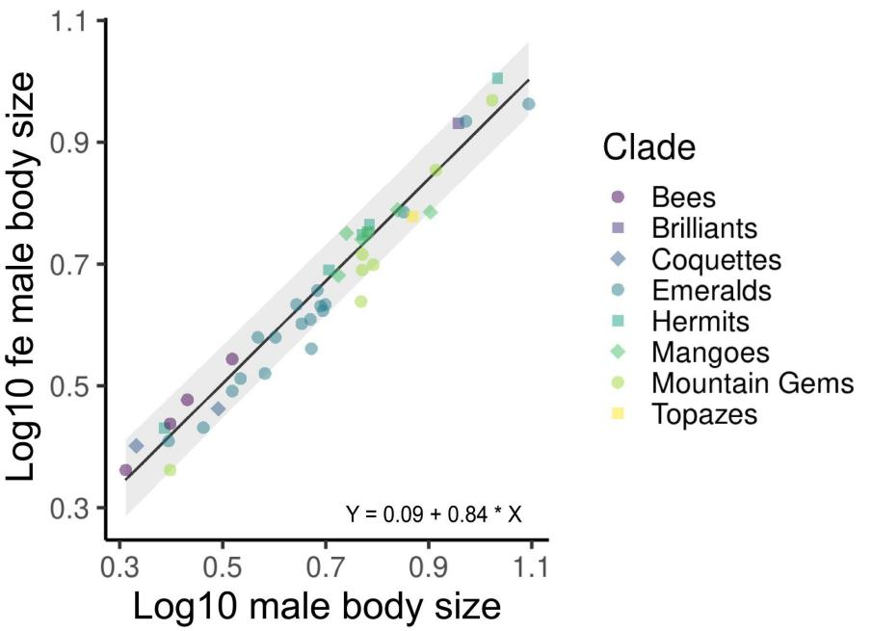
Fig. 1. Rensch’s rule in hummingbirds across Costa Rica. We built the regression from 45 species from Costa Rica and subjected the data to a phylogenetic correction.

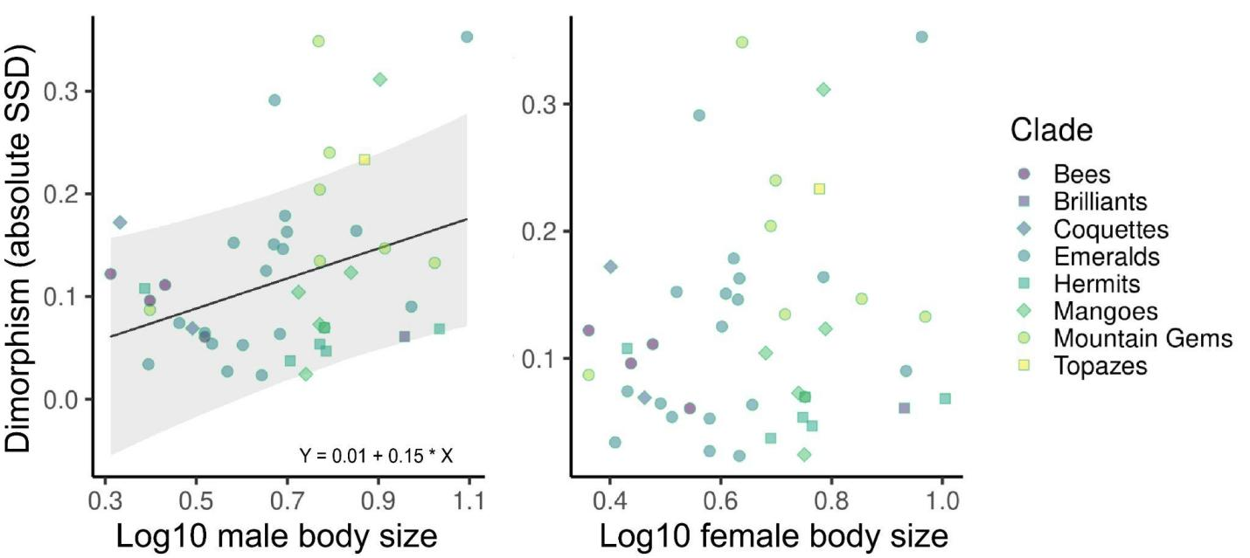

Fig. 2. Regression between the absolute sexual size dimorphism (Lovich-Gibbons Ratio) and the Log10 body mass of each sex. We perform the analyzes from 45 Costa Rican hummingbird species that underwent a phylogenetic correction.

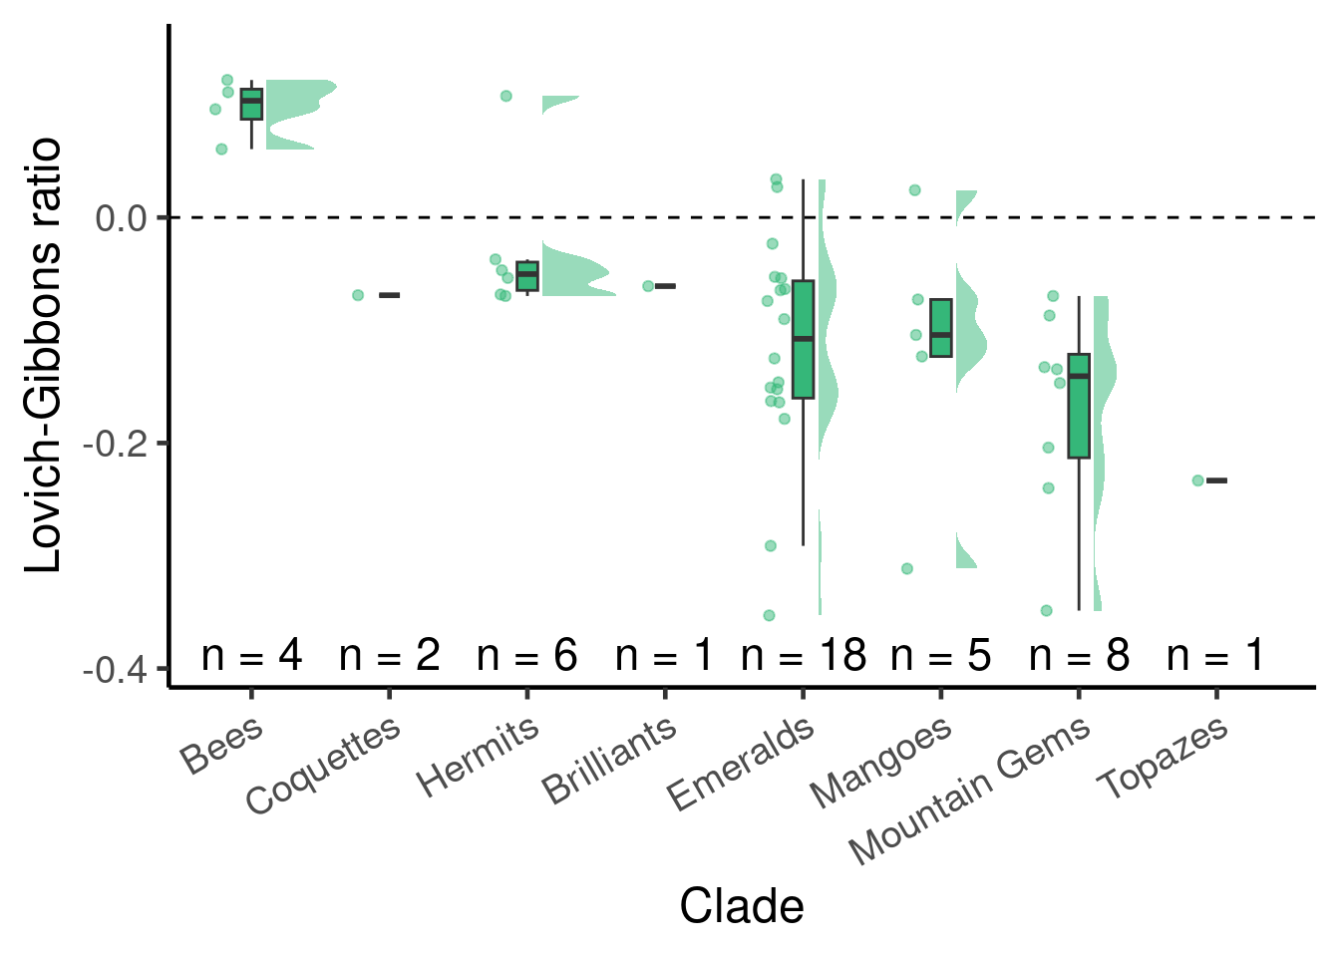
Fig. 3. Variation in the Lovich-Gibbons ratio for SSD in body mass among eight hummingbird clades following McGuire et al., (2014). Below zero, there is a male-biased allometry, and above zero there is female-biased allometry.

